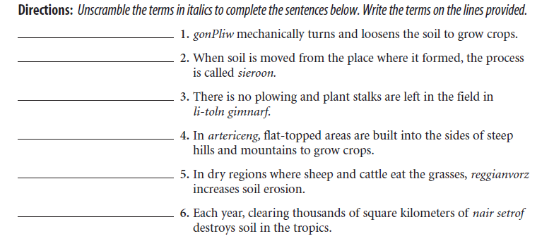
Agricultural Techniques Practice

Directions: Explain how/why the following are true.
7. Plowing fields is a non-sustainable agricultural technique because ____________________________ ____________________________________________________________________________________________________________________________________________________________________________________
8. No-till farming is a sustainable agricultural technique because ________________________________



