Climatogram Project: Temperature, Rainfall, and Biome Distribution

Welcome to your climatogram project. In this project you will investigate the relationship between the amount of rainfall and the variance of temperature and the effect on the distribution of biomes globally.

Purpose:
This project provides practice in associating climate (as expressed in monthly averages of precipitation and temperature) with biomes. You will also make predictions about the distribution of a biome via altitude and latitude.
Large ecosystems or biomes can be described in terms of their climate, or long-term weather patterns. The climate of a biome is the result of the interaction of several abiotic factors. These factors include temperature, precipitation, and radiant energy from the sun, evaporation, wind and humidity. These abiotic factors serve to limit the diversity of plants and animals found within an ecosystem. The two most important of these limiting abiotic factors are temperature and precipitation. A climatogram is a graph with a double-Y axis that plots the average monthly temperature & precipitation in a biome.
Climatograms of a large ecosystem (or biome) show variation in only two factors- temperature and precipitation. Although there are other factors that affect the climate, a climatogram does give a rough idea of the climate in a particular biome.

Score Sheet:
Part I:
Part A
- Calculations _____/8

- 4 Climatograms _____/20 (Labels, Format, Accuracy)
Part B
- Questions _____/18
Part II:
- Calculations _____/2

- Climatogram _____/5 (Labels, Format, Accuracy)

- Questions _____/8
Part III:
Academic
- 2 Climatograms _____/20 (Labels, Form, Accuracy)

- 2 Analysis Statements _____/12
Honors
- 4 Climatograms _____/20 (Labels, Form, Accuracy)

- 4 Analysis Statements _____/12

- Honors Only Questions _____/5
Appearance:
Neatness of Climatograms _____/4

Legibility of Writing _____/3

Late Deduction (-10pts per day) ________
Total Project Score (2 Lab Grades) Academic: _____/100 Honors: _____/105

Part I: Known Biomes—Building a Library of Examples

Known Biomes Part A
- Graph the climate figures for precipitation and temperature for the four locales in Known Biomes Part 1 onto your blank climatogram sheets (found at the end of the data).
  - Be sure that you label each location and its biome name.
  - Also be extremely careful as to how you record the information. All temperature readings are measured on the right side of the climatogram! All precipitation measurements are on the left side of the climatogram!
  - Be sure to draw a line graph for temperature data and a bar graph for precipitation data.
  - Use 2 different colors (not regular pencil), one for temperature and one for precipitation.
- Calculate the average temperature. See me for help if necessary. Record the value below each data table and on the climatogram.
- Calculate the total precipitation for each data set. Record the value below each data table and on the climatogram.

Cuiaba, Brazil: Tropical Deciduous Forest
 | J | F | M | A | M | J | J | A | S | O | N | D
Precipitation (in cm): | 24.9 | 21.1 | 21.1 | 10.2 | 5.3 | 0.8 | 0.5 | 2.8 | 5.1 | 11.4 | 15 | 20.6
Temperature (in C°): | 27.2 | 27.2 | 27.2 | 26.6 | 25.6 | 23.9 | 24.4 | 25.6 | 27.8 | 27.8 | 27.8 | 27.2

Average Temperature in Celsius: __________ Total Rainfall in cm: __________

Santa Monica, California: Chaparral
 | J | F | M | A | M | J | J | A | S | O | N | D
Precipitation (in cm): | 8.9 | 7.6 | 7.4 | 1.3 | 1.3 | 0 | 0 | 0 | 0.3 | 1.5 | 3.5 | 5.8
Temperature (in C°): | 11.7 | 11.7 | 12.8 | 14.4 | 15.6 | 17.2 | 18.9 | 18.3 | 18.3 | 16.7 | 14.4 | 12.8

Average Temperature in Celsius: __________ Total Rainfall in cm: __________

Moshi,Tanganyika: Tropical Grassland
 | J | F | M | A | M | J | J | A | S | O | N | D
Precipitation (in cm): | 3.6 | 6.1 | 9.2 | 40.1 | 30.2 | 5.1 | 5.1 | 2.5 | 2 | 3 | 8.1 | 6.4
Temperature (in C°): | 23.3 | 23.2 | 22.2 | 21.1 | 19.8 | 18.4 | 17.9 | 18.4 | 19.8 | 21.4 | 22 | 22.4

Average Temperature in Celsius: __________ Total Rainfall in cm: __________

Aden, Aden: Tropical Desert
 | J | F | M | A | M | J | J | A | S | O | N | D
Precipitation (in cm): | 0.8 | 0.5 | 1.3 | 0.45 | 0.3 | 0.3 | 0 | 0.3 | 0.3 | 0.3 | 0.3 | 0.3
Temperature (in C°): | 24.6 | 25.1 | 26.4 | 28.5 | 30.6 | 31.9 | 31.1 | 30.3 | 31.1 | 28.8 | 26.5 | 25.1

Average Temperature in Celsius: __________ Total Rainfall in cm: __________

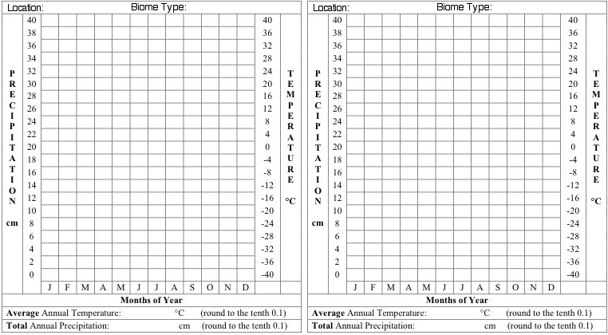

Known Biomes Part B
Combined with the six climatograms given as examples below, you now have ten climatograms representing ten different biome found worldwide.

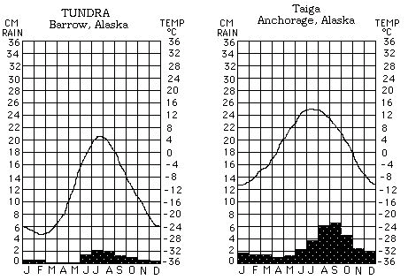
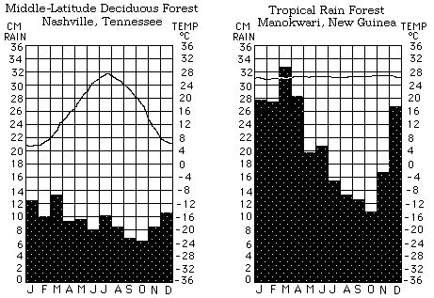

Examine the 10 climatograms for the known biomes (your 4 plus the 6 provided) and answer the questions below.

- How are the Tundra and Desert similar? Different?
  - Similar-

  - Different-

- Considering that the information in your climatograms is presented on a monthly basis. How would you determine which biomes are located in the southern hemisphere?

- Which biome has the:

  - Most rainfall

  - Least rainfall

  - The highest average temperature

  - The lowest average temperature

  - Most consistent year round temperature

  - Most variable year round temperature

Part II: San Francisco Case Study

Create the climatogram for San Francisco.
  - Be sure that you label each location and its biome name.
  - Also be extremely careful as to how you record the information. All temperature readings are measured on the right side of the climatogram! All precipitation measurements are on the left side of the climatogram!
  - Be sure to draw a line graph for temperature data and a bar graph for precipitation data.
  - Use 2 different colors (not regular pencil), one for temperature and one for precipitation.

 | J | F | M | A | M | J | J | A | S | O | N | D
Precipitation (in cm): | 4.5 | 2.8 | 2.6 | 1.5 | 0.3 | 0.1 | 0 | 0.1 | 0.2 | 1.1 | 2.5 | 3.5
Temperature (in C°): | 13.0 | 15.0 | 16.0 | 17.0 | 17.0 | 19.0 | 18.0 | 18.0 | 21.0 | 20.0 | 17.0 | 14.0

Average Temperature in Celsius: __________ Total Rainfall in cm: __________

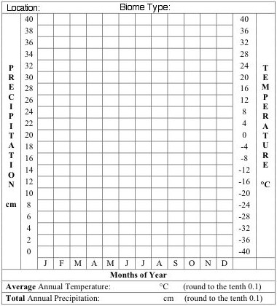

Compare the climatogram for San Francisco with the ten known Biomes from Part I and answer the following questions about San Francisco.

- Which of the known biome climatograms most closely resembles San Francisco?

  - In what ways were they similar?

  - In what ways were they different?

  - During the thirty-year period used for the figures in the San Francisco climatogram there were four drought periods. How would this effect the appearance of the climatogram?

Part III: Making Climatograms for Unknown Biomes
Academic Students: Complete climatograms and analysis statements for A & B only!
Honors Students: Complete climatograms and analysis statements for all (A-D)!

Creating climatograms for the unknown biomes/locations.
- Be sure that you label each location and its biome name.
- Also be extremely careful as to how you record the information. All temperature readings are measured on the right side of the climatogram! All precipitation measurements are on the left side of the climatogram!
- Be sure to draw a line graph for temperature data and a bar graph for precipitation data.
- Use 2 different colors (not regular pencil), one for temperature and one for precipitation.

Location: UNKNOWN A
 | J | F | M | A | M | J | J | A | S | O | N | D
Precipitation (in cm): | 25.8 | 24.9 | 31 | 16.5 | 25.4 | 18.8 | 16.8 | 11.7 | 22.1 | 18.3 | 21.3 | 29.2
Temperature (in C°): | 25.6 | 25.6 | 24.4 | 25 | 24.4 | 23.3 | 23.3 | 24.4 | 24.4 | 25 | 25.6 | 25.6

Average Temperature in Celsius: __________ Total Rainfall in cm: __________

Location: UNKNOWN B
 | J | F | M | A | M | J | J | A | S | O | N | D
Precipitation (in cm): | 1 | 1.3 | 1.8 | 1.5 | 1.5 | 1.3 | 2.3 | 2.8 | 2.8 | 2.8 | 2.8 | 1.3
Temperature (in C°): | -22.2 | -22.8 | -21.1 | -14.4 | -0.39 | 1.7 | 5 | 5 | 1.1 | -3.9 | -10 | -17.2

Average Temperature in Celsius: __________ Total Rainfall in cm: __________

Location: UNKNOWN C
 | J | F | M | A | M | J | J | A | S | O | N | D
Precipitation (in cm): | 0 | 0 | 1.5 | 0.5 | 8.9 | 14.7 | 12.2 | 8.1 | 2 | 1 | 0.3 | 0.8
Temperature (in C°): | 19.4 | 18.9 | 18.3 | 16.1 | 15 | 13.3 | 12.8 | 13.3 | 14.4 | 15 | 16.7 | 17.8

Average Temperature in Celsius: __________ Total Rainfall in cm: __________

Location: UNKNOWN D
 | J | F | M | A | M | J | J | A | S | O | N | D
Precipitation (in cm): | 9.1 | 8.9 | 8.6 | 6.6 | 5.1 | 2 | 0.5 | 0.5 | 3.6 | 8.4 | 10.9 | 10.4
Temperature (in C°): | 10.6 | 11.1 | 12.2 | 14.4 | 15.6 | 19.4 | 21.1 | 21.7 | 20 | 16.7 | 13.9 | 11.1

Average Temperature in Celsius: __________ Total Rainfall in cm: __________

Analysis Statements:
- Compare the unknown climatograms you have created to the ten known Biomes from Part I and determine the biome for each of the unknown climatograms. Record this on each climatogram.

- Write a brief explanation (3 sentences) for each unknown describing which biome you matched it to and why.
  - Identify the unknown by the letter and the matched biome by the name.
  - Be sure to discuss both temperature and precipitation patterns in your analysis.

Location: Unknown A
_________________________________________________________________________
_________________________________________________________________________
__________________________________________________________________________________________________________________________________________________

Location: Unknown B
_________________________________________________________________________
_________________________________________________________________________
__________________________________________________________________________________________________________________________________________________

Location: Unknown C
_________________________________________________________________________
_________________________________________________________________________
__________________________________________________________________________________________________________________________________________________

Location: Unknown D
_________________________________________________________________________
_________________________________________________________________________
_________________________________________________________________________
_________________________________________________________________________

- HONORS ONLY:
  - Identify which two unknowns represent the same biome.

  - Describe how they can represent the same biome even though upon first glance the patterns are distinctly different.

EXTRA CLIMATOGRAMS—CUT AND PASTE OVER ERRORS

