Practice: Motions of the Earth

- Mark each of the following as information pertaining to the Earth’s rotation or revolution:
  - _____ Takes 24 hours
  - _____ Takes 1 year
  - _____ Causes days and nights
  - _____ Spinning
  - _____ Orbit around the sun
  - _____ Heliocentric
  - _____ Counterclockwise

- Seasons:
  - Describe why the Earth has seasons.

  - Label the image below with each of the following: direction of revolution (write and use arrows), direction of rotation (write and use arrows), northern hemisphere, southern hemisphere, March, June, September, December, the hemisphere in which you live (use stars)
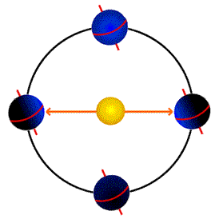

  - Complete the chart below:
Hemisphere | March |  | June |  | September |  | December
 | Direction of Tilt | Season | Direction of Tilt | Season | Direction of Tilt | Season | Direction of Tilt | Season

- Earth’s Shape:
  - Identify Earth’s shape.

  - Explain why the Earth is not a perfect sphere.

- Identify if each of the following describes precession or nutation:
  - _____ Does not affect the angle of the Earth’s tilt
  - _____ Could also be described as the Earth’s swiveling on its axis
  - _____ The reason the North Star alternated between Polaris and Vega
  - _____ Could also be described as the Earth wobbling on its axis
  - _____ Causes a 0.5° change in the Earth’s tilt
  - _____ Is caused by the moon’s gravity
  - _____ Results in the seasons being more/less extreme depending on the angle of tilt

- Illustrate precession.

- Illustrate nutation.

- Explain why the following statement is inaccurate: The Earth revolves around the sun.

- Indicate a likely location for the barycenter given the two revolving objects depicted below:

- Identify two different barycenters associated with the Earth.

