Ecosystem Structure

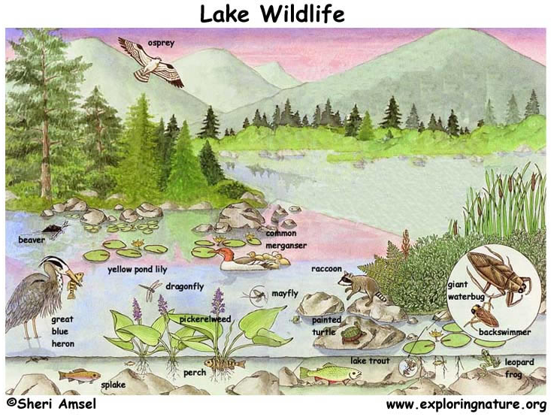
Circle and label the following within the images below: organism, population, species, community, ecosystem, biome, & biosphere

