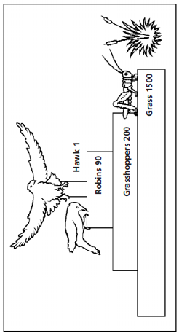
Energy Transfer Within Ecosystems

Use the trophic pyramid below to help answer the following questions:

- How many trophic levels are depicted?

- The grasshoppers are part of which trophic level?

- Which trophic level represents the secondary consumers?

- What is the ultimate source of energy for all terrestrial (land-based) ecosystems?

- Why are producers (photosynthetic organisms/plants) always in trophic level 1?

- What percentage of energy will transfer from one trophic level to the next?

- If there are 1000 kilojoules of energy in trophic level 1, what’s the maximum amount of energy for trophic level
  - 2?

  - 3?

  - 4?

- Why is the energy transfer between levels less than 100%?

- In the image above, the numbers tell how many individuals of each type of organism are present in the ecosystem. Why does the number of individuals decrease as the trophic level increases?

- Why do very few trophic pyramids have more than 4 or 5 levels?

Use the food web below to help answer the following questions:
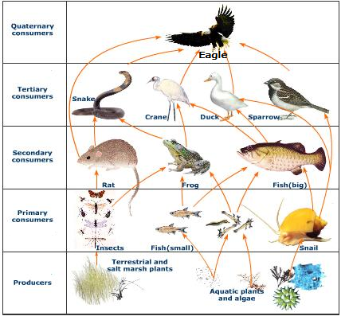
- At which level of the food web is the supply of energy the greatest? Explain.

- What feeding relationship do primary consumers have in common?

- What feeding relationship do secondary consumers have in common?

- Explain why plants are called autotrophs.

- Write the chemical equation for the reaction used by plants and other autotrophs.

- What chemical reaction breaks down food to produce usable energy for an organism? Write the chemical equation.

- Food webs and food chains both involve multiple trophic levels, how do they differ?

- Using the food web, describe a food chain that includes a crane and salt marsh plants.

- How might the organisms pictured in the food web be affected if most of the rat population was destroyed by disease?

- The eagle occupies what trophic levels of the food web?

- Describe the difference between bioaccumulation and biomagnification.

- If a chemical is used on the plants in the food web which organism with have the highest amount in its system?

- Producers and Consumers are represented in the food web, what other means of obtaining energy is missing? Why are they important for the ecosystem?

