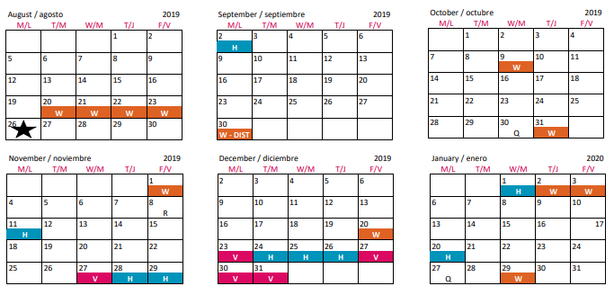
Earth Science 9 Semester Calendar Fal l 2 019
Final Exam Review
U9 TEST
U8 TEST
U7 TEST
U6 TEST
U5 TEST
U3 TEST
U2 TEST
U2 QUEST
Hurricane Dorian
U4 TEST
Formal Lab Due
Cumulative Exam
U10 TEST
NCFEs
Formal Lab Due
U1 QUEST

