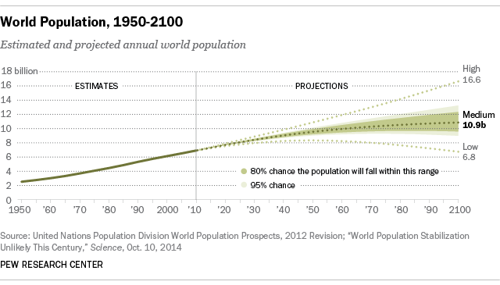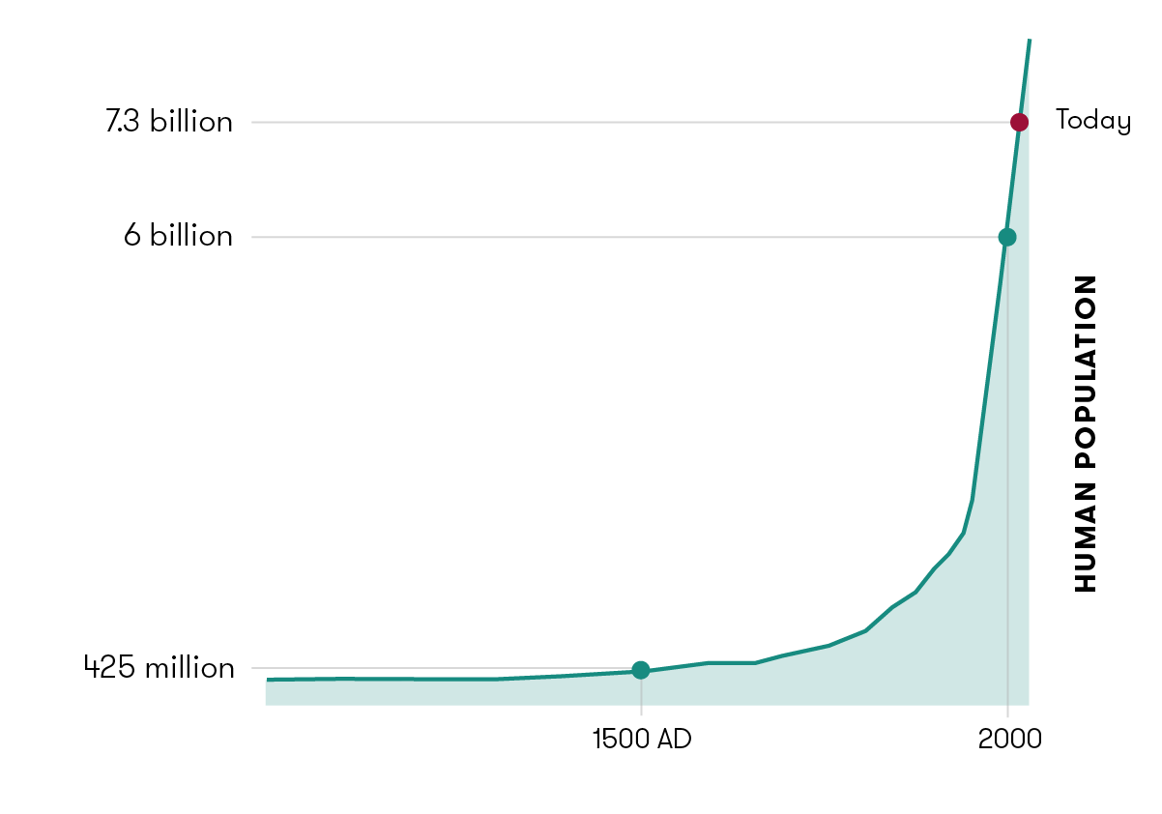

Questions:

1. Describe the type of growth.
2. What does this type of growth mean for resource use?
3. What is likely to happen in the future?
4. Why do the two graphs appear to show very different slopes?

Human Population Over Time