Population Ecology: Limiting Factors
Background:
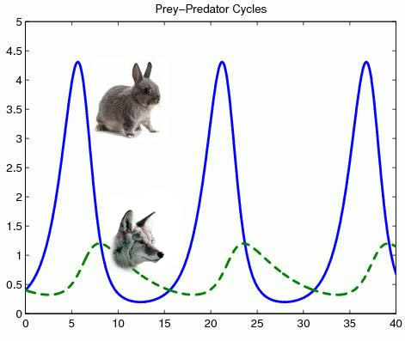
In nature, populations of organisms rarely grow uncontrolled. Each ecosystem has a carrying capacity or number of organisms it can sustain. Limiting factors are biotic and abiotic factors that prevent the continuous growth of a population. If the limiting factor plays a large enough role, the number of organisms in a population may be kept below carrying capacity. This activity will look at how different limiting factors impact population.
Procedure:
Study the Prey-Predator graph below to answer the following questions.

Scenario 1: Normal rainy season in a deciduous forest.
Coyotes feed on rabbits as one source of energy. The Prey-Predator graph shows population sizes of each species under ideal living conditions i.e. access to resources, shelter, mates, etc.
- Describe the population growth pattern for the rabbit.
___________________________________
___________________________________
______________________________________________________________________________
- Describe the population growth pattern for the coyote.
______________________________________________________________________________
______________________________________________________________________________

Scenario 2: Dry Season
Lack of rain in the forest has reduced the amount of vegetation for rabbits to feed on, the rabbit population has decreased by 50% as a result. Answer the following questions.
- How would the decrease in the rabbit population due to drought affect the survival of the coyotes?
______________________________________________________________________________
______________________________________________________________________________
- Is this an example of a density dependent or independent limiting factor? Explain.
______________________________________________________________________________
______________________________________________________________________________

Scenario 3: Competition
A population of wolves has migrated into the forest, they are in direct competition with coyotes for the rabbits. Answer the following questions.
- How would the new competition affect the survival of the coyotes?
______________________________________________________________________________
______________________________________________________________________________
- Is this an example of a density dependent or independent limiting factor? Explain.
______________________________________________________________________________
______________________________________________________________________________

Analysis:
- Read each situation in the chart below. State if it is a density-independent (D.I.) limiting factor or a density-dependent (D.D) limiting factor. Then state the specific limiting factor that is occurring.

Situation | D.I. or D.D.? | Specific Limiting Factor
Northern pike (it’s a fish) feed on another fish, the yellow perch. An increase in the yellow perch population causes an increase in the northern pike population
The BP oil spill in the Gulf of Mexico has harmed many aquatic organisms that live in the gulf region.
A new strain of influenza (the flu) breaks out in New York City.
A population of rabbits and a population of deer are both feeding off of the same plants in the same habitat
Hurricane Katrina forced thousands of people to leave New Orleans
Due to humans putting increasing amounts of greenhouse gases into the atmosphere and cutting down trees that would normally take up some of those gases, the Earth slowly gets warmer and changes climates around the globe. This affects the polar bear population.

- Deer: Predation or Starvation:
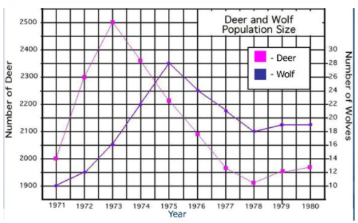
Another type of limiting factor shown in the three investigations is the predator prey relationship. However, this limiting factor is better shown over longer periods of time. Read the following and answer the questions: In 1970 the deer population of an island forest reserve about 518 square kilometers in size was about 2000 animals. Although the island had excellent vegetation for feeding, the food supply obviously had limits. Thus the forest management feared that overgrazing might lead to mass starvation. The wildlife service decided to bring in natural predators to control the deer population. They hoped that natural predation would keep the deer population from becoming too large and increase the deer overall health), as predators often eliminate the weaker members of the herd. In 1971, ten wolves were introduced. The results are shown in the following graph. The Population Change is the number of deer born minus the number of deer that died during that year.

- Describe what happened to the deer and wolf populations between 1971 and 1980.

- What do you think would have happened to the deer on the island had wolves NOT been introduced?

- Is this an example of a density dependent or independent limiting factor? Explain.

- On the graph above, label the following for the wolf population:

  - Carrying capacity
  - Biotic potential
  - Peak population
  - Exponential growth
  - Population decline

