Ocean Surface Currents Activity

Modeling Wind
Procedure
- Fill the container just below the rim with water.
- Add small pieces of aluminum foil to the top of the water.
- Getting level with the surface of the water, blow across the pie pan to create “wind”. Answer the questions below.

Analysis/Conclusions
- Describe what happened to the aluminum foil pieces/water when you blew across it.

- Once the aluminum foil pieces were out of the path of the “wind”, how did their motion change?

- What effect did the wind have on the water at the bottom of the container?

- Describe how the wind acts a force for the motion of ocean water (include a discussion of both shallow and deep water). Illustrate your explanation.

Modeling Obstacles
Procedure
- Scoop out a larger beaker full of water from your container.
- Place the beaker full of water in the center of the container (it should stick out of the water).
- Getting level with the surface of the water, blow across the pie pan to create “wind”. Answer the questions below.

Analysis/Conclusions
- Describe what happened to the aluminum foil pieces/water when you blew across it, paying particular attention to its behavior near the beaker of water.

- Describe how continents affect the movement of surface water within the oceans. Illustrate your explanation.

Modeling the Coriolis Effect
Procedure
- Blow up a balloon.
- With a marker, draw the equator on the balloon midway between the knot and the top of the balloon. Label the top North Pole and the knot South Pole.
- Hold the balloon at eye level, by the knot, and rotate it left to right, simulating the rotation of the earth.
- While 1 partner rotates the earth balloon, the other examines the movement of the earth from the North Pole perspective and from the South Pole perspective. Answer questions 1 and 2.
- While 1 partner continues to rotate the balloon steadily from left to right, the other slowly tries to draw a line straight from the North Pole, south to the equator, using a second marker. While the earth continues to rotate, 1 partner tries to draw a straight line from the South Pole, north to the equator. Answer questions 3 and 4.

Analysis/Conclusions
- As you look from the North Pole toward the equator, is the balloon spinning clockwise or counterclockwise?

- As you look from the South Pole toward the equator, is the balloon spinning clockwise or counterclockwise?

- What happened when you tried to draw a straight line from the North Pole to the equator?
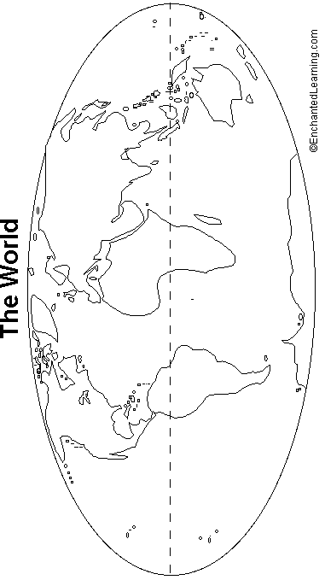

- What happened when you tried to draw a straight line from the South Pole to the equator?

- *Sketch the following surface currents on the image below. Be sure to color code them based on temperature (red for warm, blue for cold). Gulf Stream, North Atlantic Drift, Canary, North Equatorial (2), South Equatorial (2), Brazil, South Atlantic, Benguela, South Pacific, Peru, California, and North Pacific.

