Sea Level Change

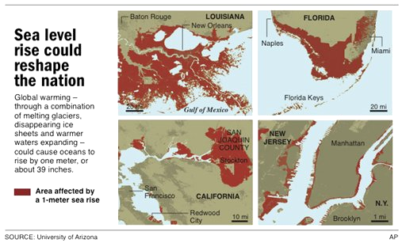
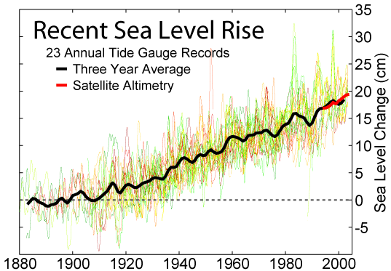

Using the graphs and maps provided, answer the following questions:
- In the last 148,000 years, when was the sea level lowest?

- Aside from the present time, when was sea level highest?

- Evaluate the accuracy of the following statement: “Global sea level has continuously increased throughout Earth’s history”.

- Estimate
  - the amount of sea level rise over the last 20 years (in cm).

  - the rise in sea level over the last 20 years as a RATE

- Climatologists at the USGS estimate that the sea level will rise 80 cm in the next century. More than 50% of the people in the U.S. live in coastal communities.
  - What impact will sea level rise have on the coastal areas of the U.S.?

  - What impact will sea level rise have on inland areas of the U.S?

- Complete the chart below summarizing causes of sea level rise and fall.
Sea Level Change | Glaciers | Ice Age | Land Area | Temperature
Rise
Fall

