Unit 7 Notes: Severe Weather—Thunderstorms, Tornadoes, and Hurricanes

- The three basic ingredients of storms are:
  - __________ energy—the fuel of the storms
  - Differences in ________________
  - __________
- The ultimate source of the heat energy is the __________.
- As air warms, it expands, grows lighter, and __________.
- Heat increases ____________________. (3:00)
- Heated air has __________ air pressure.
- Cool air contracts, grows heavy, and __________ toward the __________. (5:15)

- Thunderstorms:
  - Sort:
Stage | Information | Image
Cumulus |  | 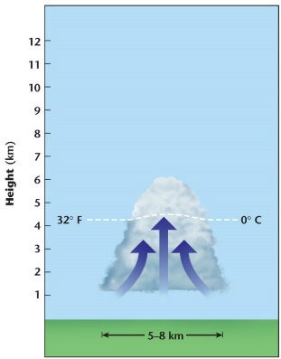
Mature |  | 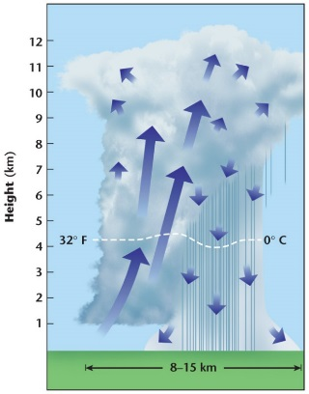
Dissipation |  | 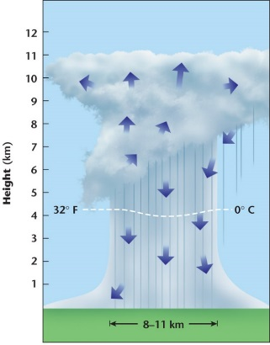
(6:50)
- Hurricanes:
  - Sort:
Stage | Information | Image
Tropical Depression
Tropical Storm
Hurricane |  | 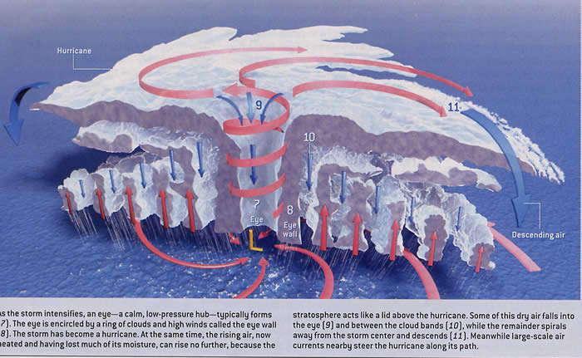
(Break up) |  | 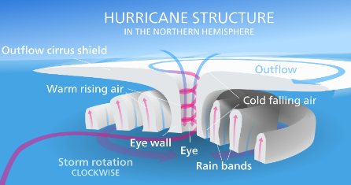

  - Winds of __________ are common and destroy __________ mostly.
  - 9 out of 10 deaths are from __________.
  - Torrential rain causes ____________________ but the deadliest water is the ocean swell called a ____________________ and may be __________ high.
  - In theory, hurricanes could last __________, but most only last a few _________.
  - Hurricanes ______ animals like sea birds that need beaches clear from growing ______. (at end of video)
- Tornadoes (10:15):
  - Tend to be __________ violent than hurricanes.
  - Develop in very unsettled air when sharply divided ____________________ air masses meet
  - Tornado alley in the south central US is the most famous site of formation: ___________ air rushing south meets ____________ air from the Gulf of Mexico.
  - Sort:
Formation Steps | Information | Image
1st |  | 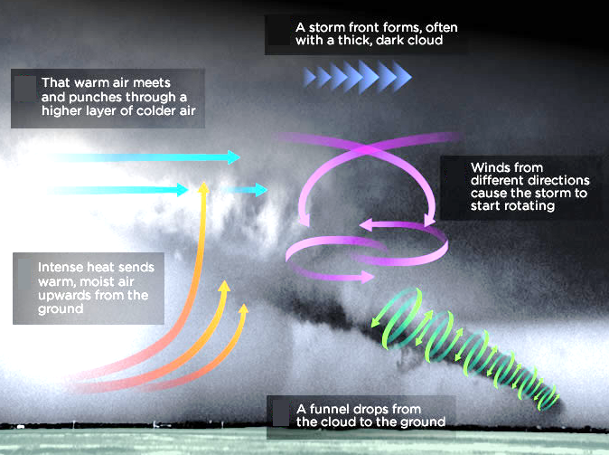
2nd
3rd
4th

  - Most only last a few __________.
  - Natural purpose
    - Release atmospheric tension between ___________________
    - Distribute __________ between the equator and the poles.
- Severe Weather Impacts: Environmental vs. Human
Type of Severe Weather | Environmental Impacts | Human Impacts
Thunderstorms
Hurricanes
Torndaoes

