Invasive Species Google or Powerpoint Slides Due: Wed 5/20
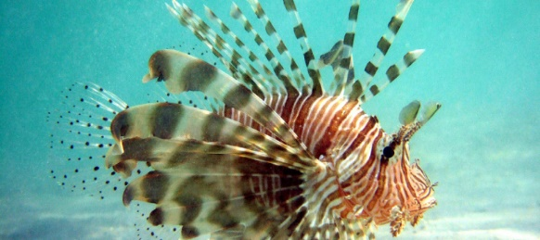
This Photo by Unknown Author is licensed under CC BY

First Read the “Cost of Invasive Species” article then choose your two species (one invasive and one endangered) to research. Finally, answer the questions (below).

You will choose 2 species total they can be a plant, animal, insect or sea creature, some resources: Encyclopedia Britanica; Washington Post, US Forest Service, world wildlife, National Wildlife Federation, Animal Planet.

- One species that is INVASIVE (not native to an area) research carefully
- One species that is ENDANGERED (becoming extinct)
- Create two slides that include:
  - Common Name of species
  - Photo
  - Where it was found initially and/or where it is now
  - What is causing it to increase/decrease in population (adaptations? No predators?)
  - Cost $$ /damages to environment and humans
  - Any other interesting facts.

Questions to answer from article:
- What is the difference between a native species, a non-native species, and an invasive species?

- What factors allow a non-native species to become invasive?

- Explain how the zebra mussel became invasive.

- Explain why the zebra mussel spread so quickly and how it could have been transferred to the west coast of the U.S.

- Identify at least three different species that are invasive in NC an how they were introduced.

- Be specific: what type of harm can an invasive species cause?

- Identify 4 ways in which invasive species disrupt ecosystems

- What are the best methods of PREVENTING invasive species?

- Identify 3 other species that are invasive in the US (use your device or laptop) and explain how they were introduced and how they have been controlled.

