Unit 3 Notes: Soil

Soil Composition
- ________________________________________________________________________
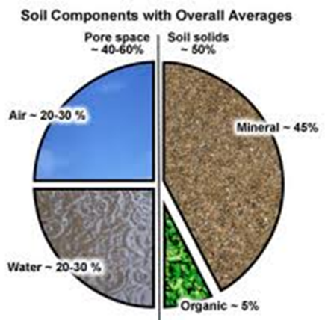
  - _______________________________________________

  - _______________________________________________

  - _______________________________________________

  - _______________________________________________

Soil Formation
- ________________________________________________________________________

  - ___________________________________________________________________

  - ___________________________________________________________________

  - ___________________________________________________________________

- ________________________________________________________________________

  - ___________________________________________________________________

  - ___________________________________________________________________

  - ___________________________________________________________________

Rate (Speed) of Soil Formation
- ________________________________________________________________________

  - _______________________________________________

  - _______________________________________________
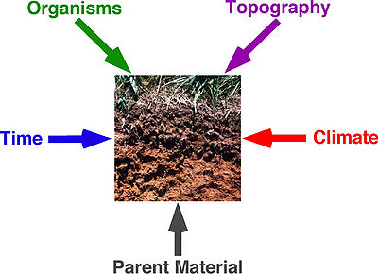
  - _______________________________________________

  - _______________________________________________

  - _______________________________________________

  - _______________________________________________
Rate of Soil Erosion
- ________________________________________________________________________

- ________________________________________________________________________

  - ___________________________________________________________________

  - ___________________________________________________________________

  - __________________________________________________________________

  - ___________________________________________________________________

Soil Profile
- ________________________________________________________________________
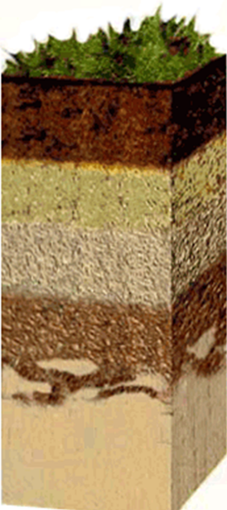
  - _____________________________________________________

  - _____________________________________________________

  - _____________________________________________________

  - _____________________________________________________

  - _____________________________________________________

  - _____________________________________________________ Label this!!!

TURN PAGE OVER!

- Soil Texture Activity
There are four soil samples at your table. Take a small amount of each soil and rub it between your fingers. Write a description of each soil’s texture on the post-it notes at your table.

Sand Silt Clay

Size: ________________________ Size: ________________________ Size: ________________________
Texture: _____________________ Texture: _____________________ Texture: _____________________
Loam

- Notes: Loam Soil
  - Mixture of ____________________________________________
    - __________________________________
  - Ideal ______________________________
    - ______________________________________________
______________________________________________
Size: ________________________
Texture: _____________________

Station: Particle Size
- ________________________________________________________________________
Station: Texture
- ________________________________________________________________________
Station: Porosity
- ________________________________________________________________________
Station: Permeability and Holding Capacity
- ________________________________________________________________________

- ________________________________________________________________________
Soil Types
- Loam—_________________________________________________________________

  - __________________________________________________________________

Type | Particle Size | Porosity/ Aeration  (Air space) | Permeability  (Water drainage) | Water/Nutrient Holding Capacity
Sand
Silt
Clay
Stations: Summarize your findings for each property of the soil types. Use comparative terms (high, low, big, small, etc.)

