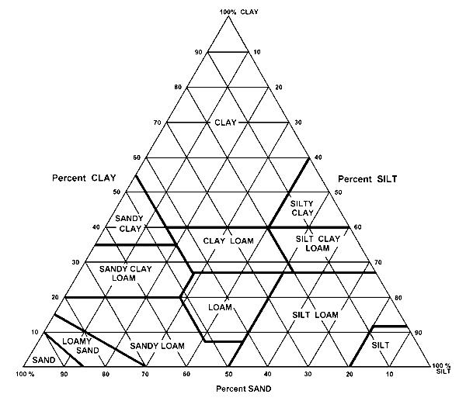
Unit 3 Notes/Practice: Soil Type/Texture Triangle
Soil Texture Practice Worksheet
Use the following percents of sand, silt, and clay to determine the soil texture name using the textural triangle provided. In the spaces where a number is missing, fill in the appropriate blanks with its correct value.
NOTE: The sum of percent sand, silt, and clay should always add up to 100%.

 | % Sand | % Silt | % Clay | Soil Texture Name
a | 75 | 10 | 15 | Sandy Loam
b | 10 | 83
c | 42 |  | 37
d |  | 52 | 21
e |  | 35 | 50
f | 30 |  | 55
g | 37 |  | 21
h | 5 | 70
i | 55 |  | 40
j |  | 45 | 10
k | 35 | 15
l | 52 |  | 44
m | 98 |  | 2

