Unit 7 Formative Assessment: Severe Weather & Climate

- Climate
  - The four factors that determine an area’s climate are:

1. (Most Important)___________________
2. _________________________________
3. __________________________________
4. __________________________________

  - Explain why #1 is the most important factor in determining climate.

- Match each Koppen climate zone to its description:

  - Humid Tropical

  - Dry

  - Humid Mid-Latitude

  - Continental

  - Polar

  - Severe winters; mild summers; north of the equator; Quebec, Canada
  - High temperatures year-round; no seasons; high humidity; near equator; Puerto Rico
  - Mild winters; hot, humid summers; consistently moderate precipitation; North Carolina
  - Coldest; little precipitation; times of continuous light and continuous darkness; Antarctica
  - Hot summers; cool winters; little precipitation; arid; New Mexico

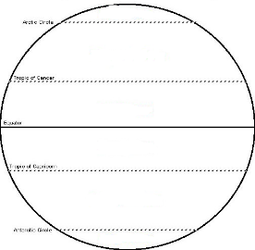
- Label the latitude zones as they pertain to climate.

- Which of the following are used to categorize an area’s climate in the Koppen Climate Classification System? (You may choose more than one.)

  - Temperature
  - Elevation
  - Latitude
  - Precipitation
  - Pressure
  - Vegetation

- Circle the words that make each statement below true:
  - Places at higher elevations tend to be (warmer/colder) than places at lower elevation.
  - Places near water have more (extreme/moderate) climates than places further from water.
  - As latitude increases, the intensity (strength) of the solar radiation (increases/decreases).
  - Arid climates are (wet/dry).
  - Humid climates are (wet/dry).
  - The amount of carbon dioxide in Earth’s atmosphere is currently (increasing/decreasing) at a very (rapid/slow) rate.
  - Historically, the global temperature has (increased/decreased/gone up & down).
  - In the last 100 years, Earth’s temperature has (increased/decreased).
  - The concern over the recent change in Earth’s temperature is because the speed of change is much (faster/slower) than in the past.

- Identify 3 impacts of global warming.

- Greenhouse gases:
  - Identify the two most important heat-absorbing (greenhouse) gases in the lower atmosphere.

  - List 3 natural sources for each of the gases named above.

  - List 3 man-made sources for each of the greenhouse gases named.

- The trapping of heat in lower layer of the atmosphere by certain gases is the _____________________.
  - Complete the statement below to describe how the above process works:
________, ________, and methane from [non-human/man-made] sources rise into the atmosphere and [absorb/reflect] heat back to [Earth/space] during the [day/night].

  - Complete the statement below to describe how the ENHANCED GREENHOUSE EFFECT works.
________, ________, and methane from [non-human/man-made] sources rise into the atmosphere, [increasing/decreasing] the total amount of greenhouse gases, and [absorb/reflect] even [more/less] heat back to [Earth/space] during the [day/night], causing an overall [decrease/increase] in global temperatures.

  - What is the main source of carbon dioxide entering Earth’s atmosphere today?

  - Explain how burning fossil fuels contributes to the enhanced greenhouse effect.

- Complete the following chart comparing El Nino and La Nina:
Event | Tradewind Strength | Amount of Upwelling | Pacific Ocean Surface Temperature | Weather Patterns
El Nino
La Nina

- Complete the chart below concerning the 8 natural causes of climate change:
Short-term OR Long-term | Event | Effect on Climate
 | Numerous volcanic eruptions releasing small ash particles
 | Numerous forest fires
 | Hemisphere tilted toward the sun
 | La Nina
 | Higher than average solar flares
 | Increased water area
 | Lesser degree of tilt
 | More circular orbit

- What is the pH range of acid rain?

- Circle the chemical(s) are responsible for acid rain formation.

  - Sulfur dioxide
  - Carbon dioxide
  - Nitrogen oxides

- What is the main cause of acid deposition in the northeast United States?

- Ground-level ozone
- Nitrogen from volcanic eruptions
- Methane from thawing Siberian lakes
- Sulfur dioxide from burning coal

- What 3 pieces of information are included in the Air Quality Index?

- Use the climatograms provided to answer each of the following questions:
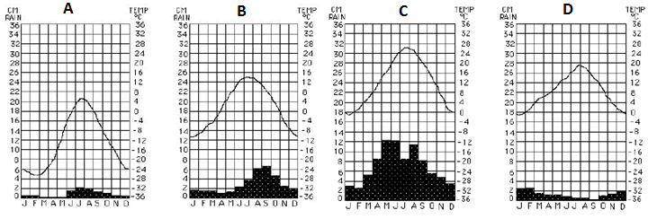

- What is the temperature range for B? __________
- How much rain does A get in August? __________
- Which of the four locations has the greatest average amount of rainfall? __________
- What is the average temperature of D in January? __________
- Which location is in the Polar climate zone? __________
- Which location is in the Dry climate zone? __________
- Describe the climate for C. When are the warm/cold and wet/dry seasons?

- Identify if each of the following describes tornadoes (T), thunderstorms (Th), and/or hurricanes (h).

- Very low pressure _____
- Is the most violent _____
- Draws in cold downdrafts _____

- Has updrafts of warm, moist air _____
- Has high pressure system above _____
- Require heat, moisture, and differences in air pressure _____

- Thunderstorms:
- List the three stages in order:

- Identify the correct stage for the formation and break up events below AND put them in order:

    - Precipitation begins _____/_____
    - Updrafts decrease _____/_____
    - Most intense stage _____/_____
    - Cloud formation _____/_____
    - Updrafts & downdrafts form convection cell _____/_____
    - Warm air runs out _____/_____

- Put the 4 steps of tornado formation in order:
  - ______ Spinning hot air stretches/funnels back down to the ground
  - ______ Plume of hot air pushes up through cold air
  - ______ Hot air trapped below cold air
  - ______ Horizontal wind (3 miles above Earth) hits & spins the hot air plume very fast

- Hurricanes:
- Where do most develop?

- Why do most develop in the area identified above?

- What two systems must form and where in relation to each other in order for thunderstorms to develop into a hurricane?

- Identify the stage of hurricane formation (Tropical Depression, Tropical Storm, or Hurricane) AND put them in order:

  - _____/______ 20-40 mph wind
  - _____/______ winds >75 mph
  - _____/______ winds 40-75 mph
  - _____/______ thunderstorms combine

  - _____/______ low pressure over tropical waters cause thunderstorms
  - _____/______ anticyclone (high pressure) above cyclone
  - _____/______ anticyclone pushes rising air & clouds out/away, preventing downdrafts
- Differentiate between the weather associated with the eye and eyewall of a hurricane.
Eye:
Eyewall:
- Explain what happens to a hurricane after it makes landfall.

- Match each weather instrument/tool to its description:

- Anemometer
- Barometer
- Hygrometer
- Psychrometer
- Rain Gauge
- Satellite
- Thermometer
- Weather Balloon
- Wind Vane/Sock

- Measures temperature in Fahrenheit or Celsius
- Measure air pressure in mm or in of mercury
- Measures cloud cover, precipitation, & tracks air mass movement
- Measures wind speed in mph or knots
- Measures actual humidity in mL/cm³
- Measures relative humidity as a percentage
- Measures amount of rain fall in cm or in
- Measures wind direction on a compass (N, E, etc.)
- Is used to position other instruments higher in Earth’s atmosphere

- Identify if each of the following describes tropospheric (ground-level) ozone, stratospheric ozone, or both:

- Increases respiratory diseases _____
- Slows photosynthesis _____
- Absorbs UV energy _____
- Causes damage to cells _____
- Affected by CFCs _____
- Composed of O₃ (3 oxygens) _____
- Ozone layer _____
- Causes cancer _____

