Name: _________________________ Unit 5 Notes: Waste Water Treatment
1. | Description | 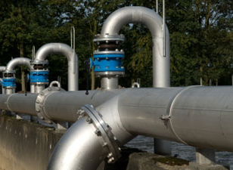
 | Purpose
2. | Description | 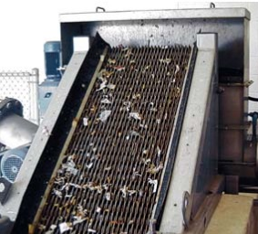
 | Purpose
3. | Description | 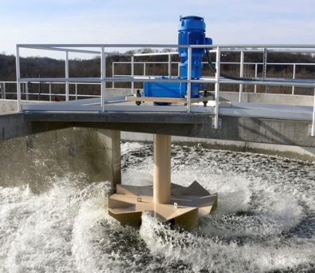
 | Purpose
4. | Description | 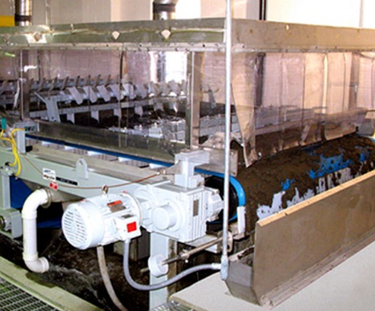
 | Purpose
5. | Description | 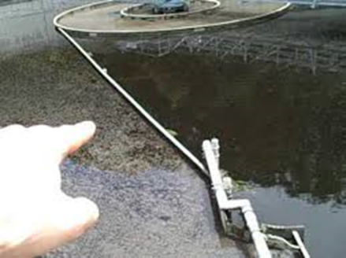
 | Purpose
6. | Description | 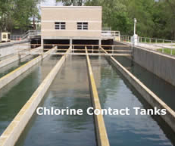
 | Purpose
7. | Description | 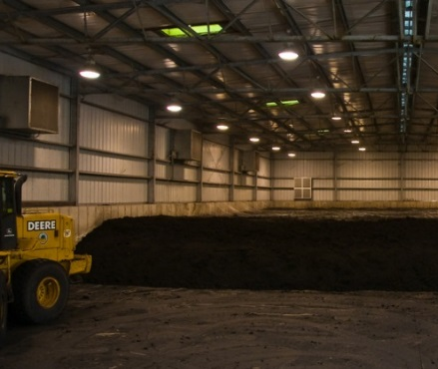
 | Purpose
Go to http://ga.water.usgs.gov/edu/wuww.html Read what wastewater is, why we treat it and answer the following questions.
- Wastewater is…

- What are some reasons we treat wastewater?
a.
b.
c.
d.

- Identify and briefly describe the steps of the wastewater treatment process.
