Water Pollution Worksheet
- Define point source pollution. Give two examples. (page 108)

- Define nonpoint source pollution. Give at least three examples. (page 109)

- Major Types of Water Pollution (page 109)
Type | Examples | Sources | Effects
Disease organisms

 | Animal manure and plant debris that bacteria decompose
 |  | Industrial effluent, urban runoff, household cleaners | Poisons fresh water and can sicken those who drink it
 |  |  | Some cancers, disorders of nervous and reproductive systems
 | Water soluble compounds with nitrate, phosphorous ions
 |  | Erosion | Disrupts aquatic food webs, clogs lakes and reservoirs, reduces photosynthesis of aquatic plants
 | Radon, uranium, radioactive iodine
- What is the biggest pollution issue for streams and rivers in North Carolina?

- Why is fertilizer a pollutant if it is needed by plants?

- Where do disease organisms that pollute waters come from?

A family tested their drinking water well to check the water quality. The test results are show in the table below. Drinking Water Sample Test Results
Lead | 0.2 parts per million
Copper | 0.006 parts per million
pH | 5.0
Coliform | 5 out of 5 samples positive

- The family suspects that their septic tank is polluting the well. What evidence exists to support their conclusion?

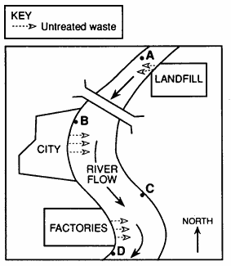
- Basing your answer on the diagram below, at which location would the water probably be most polluted, site A, B, C, or D? Explain why.

